**Get a Grip!**

**Do you have trouble opening jars and carrying objects? Do you feel that your hands and grip strength are a limiting factor to you leading a full and productive life? Then read on because grip strength is even more important than we give it credit for.**  
  
 Grip strength is now considered an important biomarker of mortality. Similar to how low bone density (osteopenia/osteoporosis), high blood pressure, 30 second sit to stand test, and lipid profiles are also biomarkers that can potentially predict mortality.  Evidence is beginning to show there is a predictive link between grip strength and all-cause and disease-specific mortality, future function, bone mineral density, fractures, cognition and depression, and problems associated with hospitalization. Furthermore, evidence is showing that the routine use of grip strength can be recommended as a stand-alone measurement or as a component of a small battery of measurements for identifying older adults at risk of poor health status.

Ok, so now we know that grip strength is important to your health, as well as your ability to do the things that you continue to love to do. So, what can you do about it? Biology prunes what it doesn’t use. Bones, muscles, skin, and our nervous system atrophies with disuse. You can reverse a lot of this atrophy, but it does take time and some effort. It also helps to have a plan of attack. A guided strength training program with a qualified personal trainer can go a long way to helping you get back to a level where you feel more confident doing the things you enjoy. I’m going to show some tidbits and tools below to get you started. If you have any questions, please feel free to reach out!

**Strengthening**

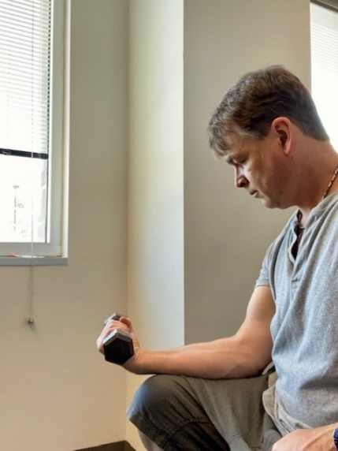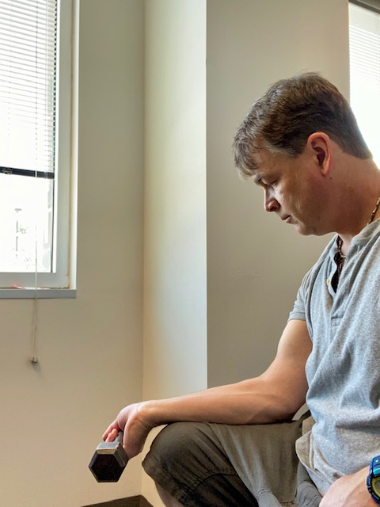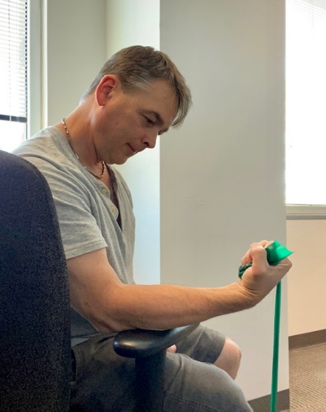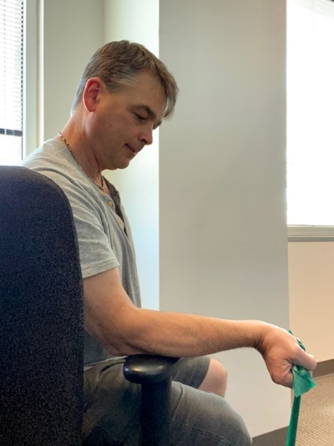**Wrist flexion**- Use water bottle, dumbbell, or even elastic band and begin with palm facing up with item in hand. Allow wrist to bend down to floor. Keep it pain free. Pause for a moment and then bend wrist back up to above starting position. Repeat at sets and repetitions encouraged by your trainer.

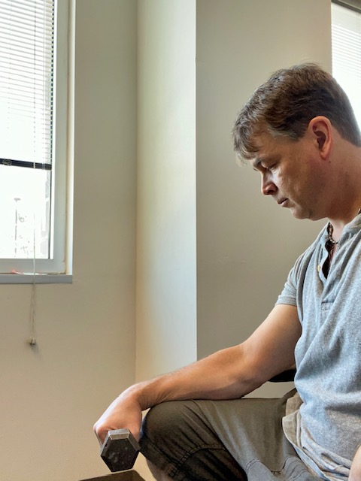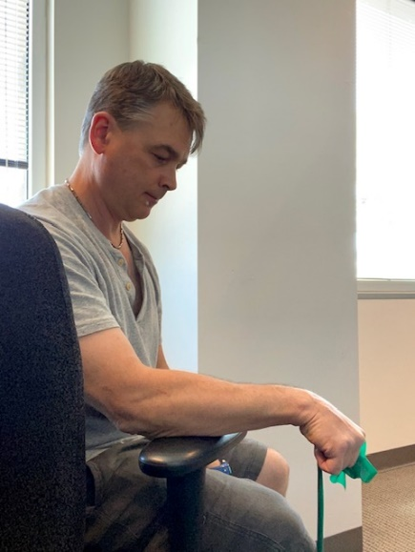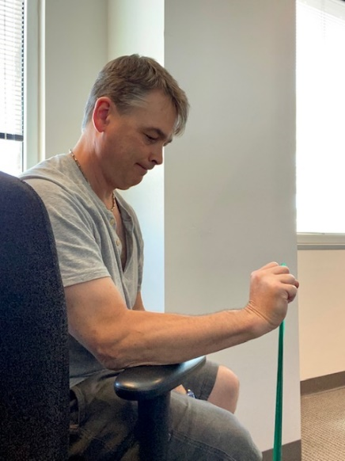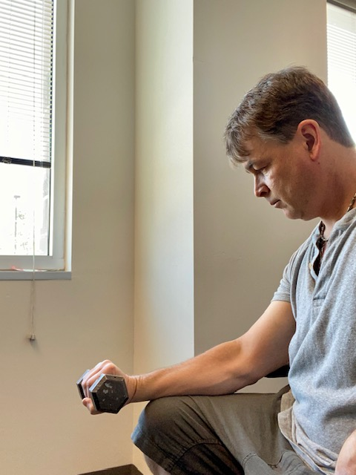**Wrist extension** – Use water bottle, dumbbell, or even elastic band and begin with palm facing down with item in hand. Allow wrist to bend down to floor. Keep it pain free. Pause for a moment at the bottom and then bend wrist back up to above starting position. Repeat at sets and repetitions encouraged by your trainer.

**Pronation/Supination** -Use water bottle, dumbbell, or even elastic band and begin with palm facing down with item in hand. Keeping wrist in neutral position. Rotate hand to the palms up position. Keep it pain free. Pause for a moment and then slowly return to starting position. Repeat at sets and repetitions encouraged by your trainer.

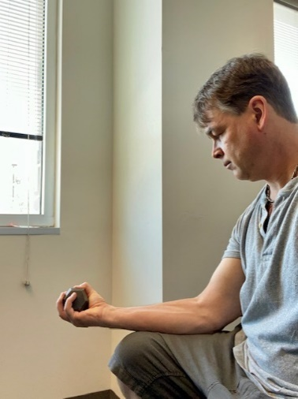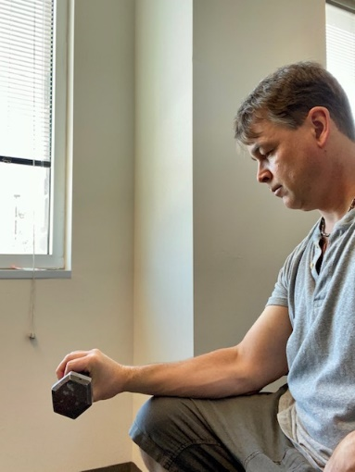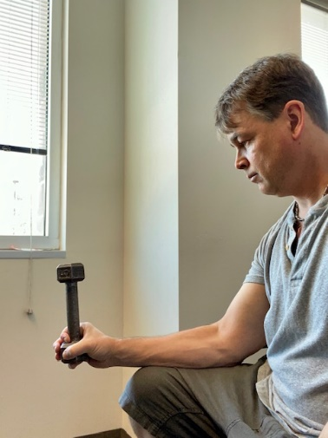

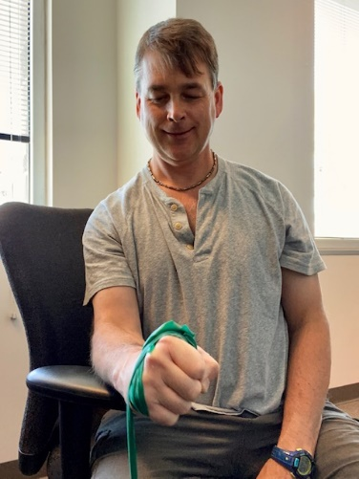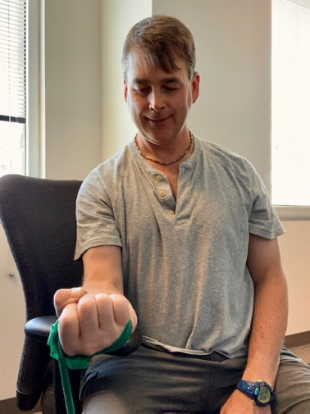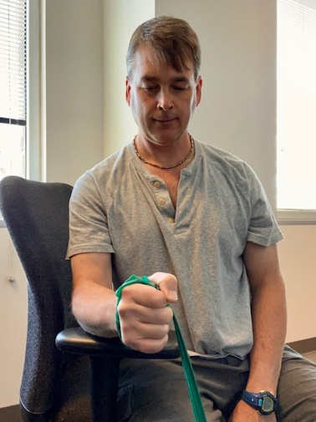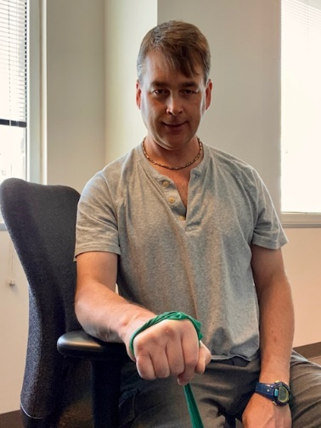

**Radial Deviation** -Use water bottle, dumbbell, or even elastic band and begin with thumb side up with item in hand. Allow wrist to bend down with pinky side going down to floor. Pause and then slowly return to starting position. Repeat at sets and repetitions encouraged by your trainer. One can challenge this activity by holding the end of the resistance thus increasing lever.

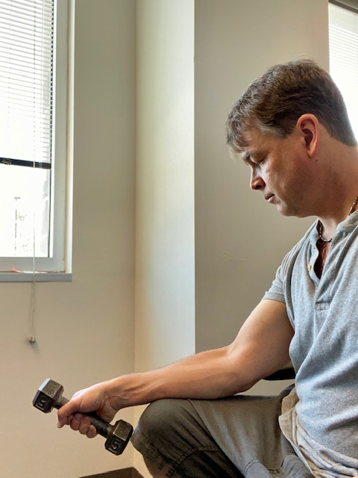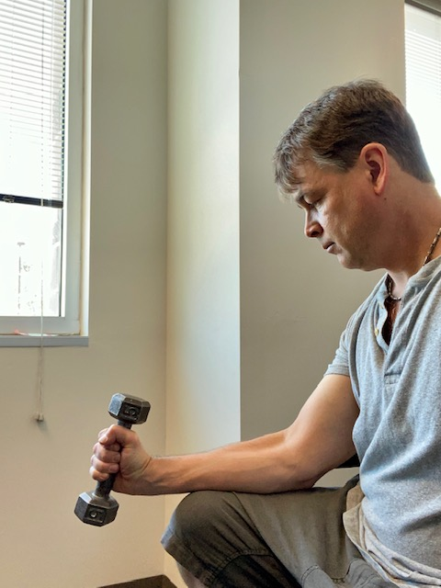

**Ulnar deviation** Use water bottle, dumbbell, or even elastic band and begin with forearm in neutral position with arm down by your side. Allow wrist to bend down with pinky side going up and back. Pause and then slowly return to starting position. Repeat at sets and repetitions encouraged by your trainer. One can challenge this activity by holding the end of the resistance thus increasing lever.

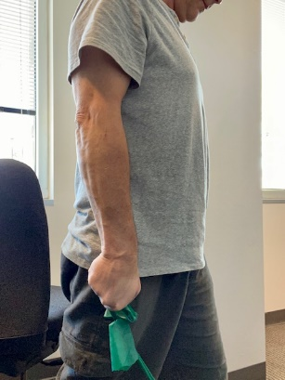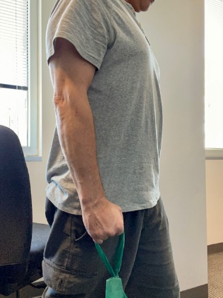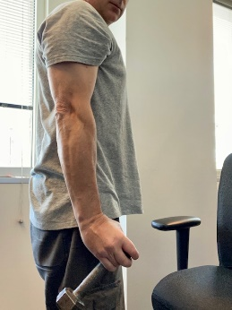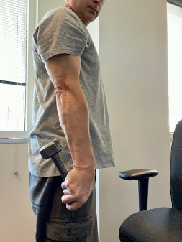

**Finger extension** -Use rubber band, hair tie, or elastic rubber band as resistance. Start with fingers in closed position (like gripping a pencil) and extend fingers out as wide as you can. This can be done with elbows bent or straight at your therapists discretion. Also, repeat at sets and repetitions encouraged by your trainer.

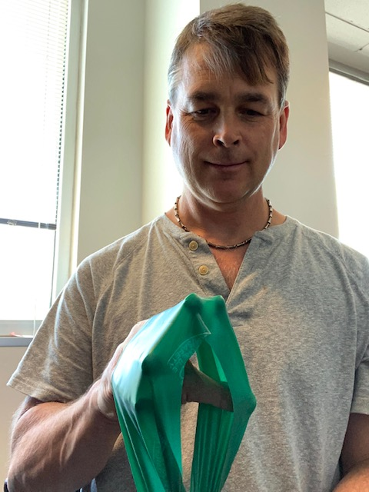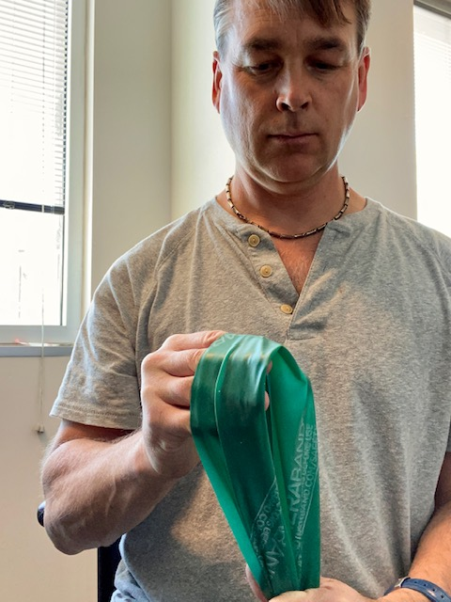

**Gripping** -Grab putty and squeeze. Don’t squeeze into sharp pain. Increase force, putty strength, and time of squeezing over time!

